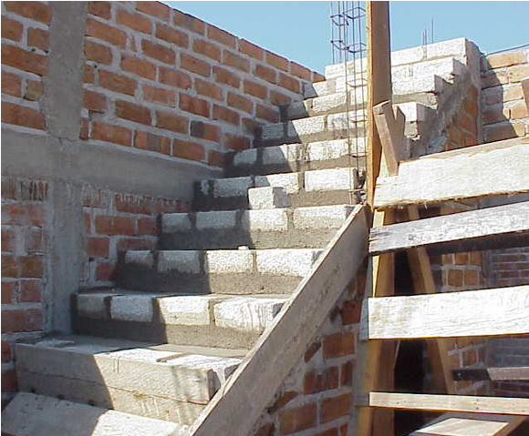

http://www.manualino.com/costruire-una-scala-in-muratura-1008/

