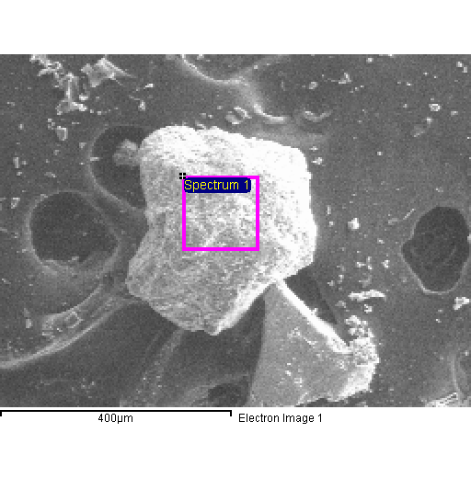
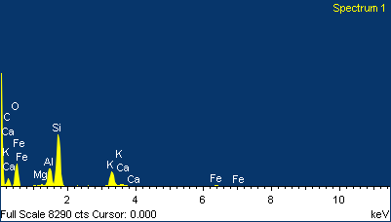

Project 1
20/04/2015 10:38:09
Comment:
Spectrum processing :
No peaks omitted

Processing option : All elements analyzed (Normalised)
Number of iterations = 5

Standard :
C CaCO3 1-Jun-1999 12:00 AM
O SiO2 1-Jun-1999 12:00 AM
Mg MgO 1-Jun-1999 12:00 AM
Al Al2O3 1-Jun-1999 12:00 AM
Si SiO2 1-Jun-1999 12:00 AM
K MAD-10 Feldspar 1-Jun-1999 12:00 AM
Ca Wollastonite 1-Jun-1999 12:00 AM
Fe Fe 1-Jun-1999 12:00 AM

Element | Weight% | Atomic%
C K | 30.97 | 42.52
O K | 41.08 | 42.35
Mg K | 0.39 | 0.26
Al K | 4.73 | 2.89
Si K | 15.13 | 8.88
K K | 5.97 | 2.52
Ca K | 0.53 | 0.22
Fe K | 1.21 | 0.36
Totals | 100.00

