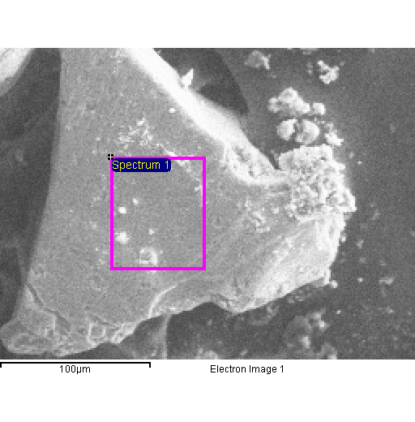
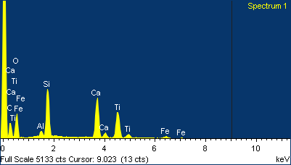

Project 1
20/04/2015 10:41:46
Comment:
Spectrum processing :
No peaks omitted

Processing option : All elements analyzed (Normalised)
Number of iterations = 4

Standard :
C CaCO3 1-Jun-1999 12:00 AM
O SiO2 1-Jun-1999 12:00 AM
Al Al2O3 1-Jun-1999 12:00 AM
Si SiO2 1-Jun-1999 12:00 AM
Ca Wollastonite 1-Jun-1999 12:00 AM
Ti Ti 1-Jun-1999 12:00 AM
Fe Fe 1-Jun-1999 12:00 AM

Element | Weight% | Atomic%
C K | 22.42 | 34.43
O K | 41.59 | 47.97
Al K | 1.04 | 0.71
Si K | 9.59 | 6.30
Ca K | 11.93 | 5.49
Ti K | 12.06 | 4.65
Fe K | 1.37 | 0.45
Totals | 100.00

