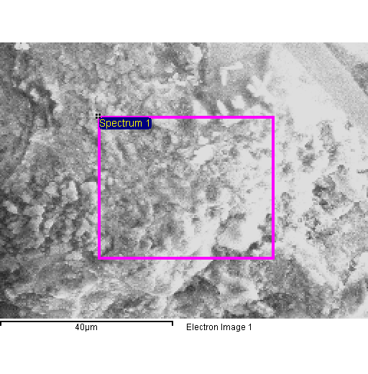
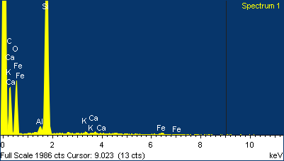

Project 1
20/04/2015 10:53:30
Comment:
Spectrum processing :
Peak possibly omitted : 2.620 keV

Processing option : All elements analyzed (Normalised)
Number of iterations = 5

Standard :
C CaCO3 1-Jun-1999 12:00 AM
O SiO2 1-Jun-1999 12:00 AM
Al Al2O3 1-Jun-1999 12:00 AM
Si SiO2 1-Jun-1999 12:00 AM
K MAD-10 Feldspar 1-Jun-1999 12:00 AM
Ca Wollastonite 1-Jun-1999 12:00 AM
Fe Fe 1-Jun-1999 12:00 AM

Element | Weight% | Atomic%
C K | 48.47 | 60.24
O K | 31.27 | 29.17
Al K | 0.40 | 0.22
Si K | 18.99 | 10.09
K K | 0.20 | 0.08
Ca K | 0.19 | 0.07
Fe K | 0.48 | 0.13
Totals | 100.00

