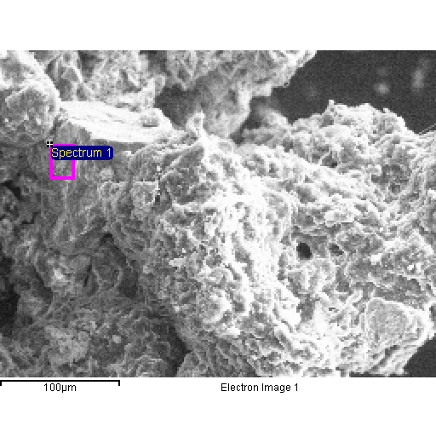
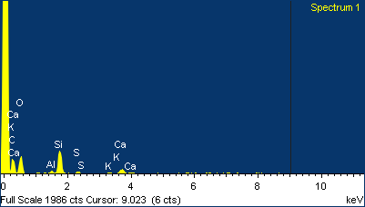

Project 1
20/04/2015 11:09:46
Comment:
Spectrum processing :
No peaks omitted

Processing option : All elements analyzed (Normalised)
Number of iterations = 4

Standard :
C CaCO3 1-Jun-1999 12:00 AM
O SiO2 1-Jun-1999 12:00 AM
Al Al2O3 1-Jun-1999 12:00 AM
Si SiO2 1-Jun-1999 12:00 AM
S FeS2 1-Jun-1999 12:00 AM
K MAD-10 Feldspar 1-Jun-1999 12:00 AM
Ca Wollastonite 1-Jun-1999 12:00 AM

Element | Weight% | Atomic%
C K | 49.06 | 58.83
O K | 39.95 | 35.96
Al K | 0.77 | 0.41
Si K | 6.91 | 3.54
S K | 0.66 | 0.29
K K | 0.48 | 0.18
Ca K | 2.17 | 0.78
Totals | 100.00

