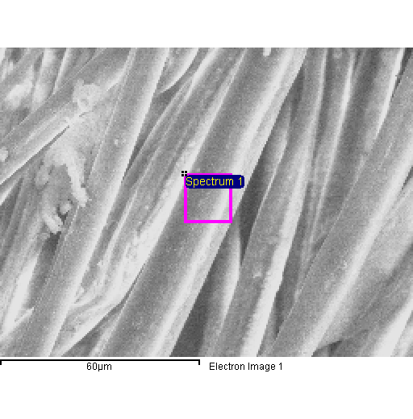
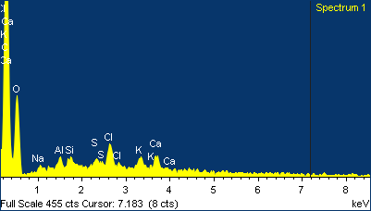

Project 1
20/04/2015 11:30:57
Comment:
Spectrum processing :
No peaks omitted

Processing option : All elements analyzed (Normalised)
Number of iterations = 4

Standard :
C CaCO3 1-Jun-1999 12:00 AM
O SiO2 1-Jun-1999 12:00 AM
Na Albite 1-Jun-1999 12:00 AM
Al Al2O3 1-Jun-1999 12:00 AM
Si SiO2 1-Jun-1999 12:00 AM
S FeS2 1-Jun-1999 12:00 AM
Cl KCl 1-Jun-1999 12:00 AM
K MAD-10 Feldspar 1-Jun-1999 12:00 AM
Ca Wollastonite 1-Jun-1999 12:00 AM

Element | Weight% | Atomic%
C K | 61.58 | 69.61
O K | 33.36 | 28.31
Na K | 0.48 | 0.28
Al K | 0.59 | 0.30
Si K | 0.37 | 0.18
S K | 0.28 | 0.12
Cl K | 1.50 | 0.58
K K | 0.77 | 0.27
Ca K | 1.06 | 0.36
Totals | 100.00

