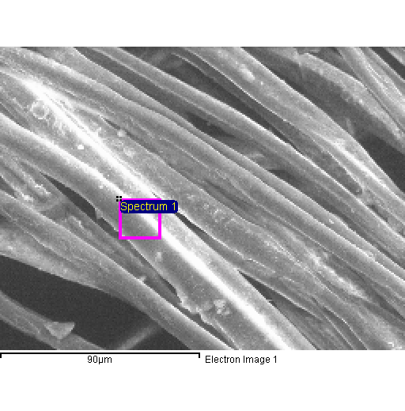
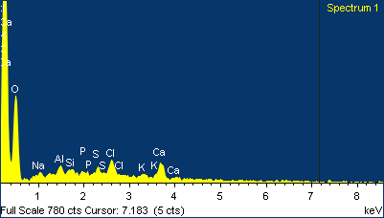

Project 1
20/04/2015 11:37:51
Comment:
Spectrum processing :
No peaks omitted

Processing option : All elements analyzed (Normalised)
Number of iterations = 4

Standard :
C CaCO3 1-Jun-1999 12:00 AM
O SiO2 1-Jun-1999 12:00 AM
Na Albite 1-Jun-1999 12:00 AM
Al Al2O3 1-Jun-1999 12:00 AM
Si SiO2 1-Jun-1999 12:00 AM
P GaP 1-Jun-1999 12:00 AM
S FeS2 1-Jun-1999 12:00 AM
Cl KCl 1-Jun-1999 12:00 AM
K MAD-10 Feldspar 1-Jun-1999 12:00 AM
Ca Wollastonite 1-Jun-1999 12:00 AM

Element | Weight% | Atomic%
C K | 61.38 | 69.11
O K | 34.58 | 29.23
Na K | 0.38 | 0.23
Al K | 0.45 | 0.23
Si K | 0.19 | 0.09
P K | 0.24 | 0.10
S K | 0.33 | 0.14
Cl K | 0.94 | 0.36
K K | 0.24 | 0.08
Ca K | 1.25 | 0.42
Totals | 100.00

