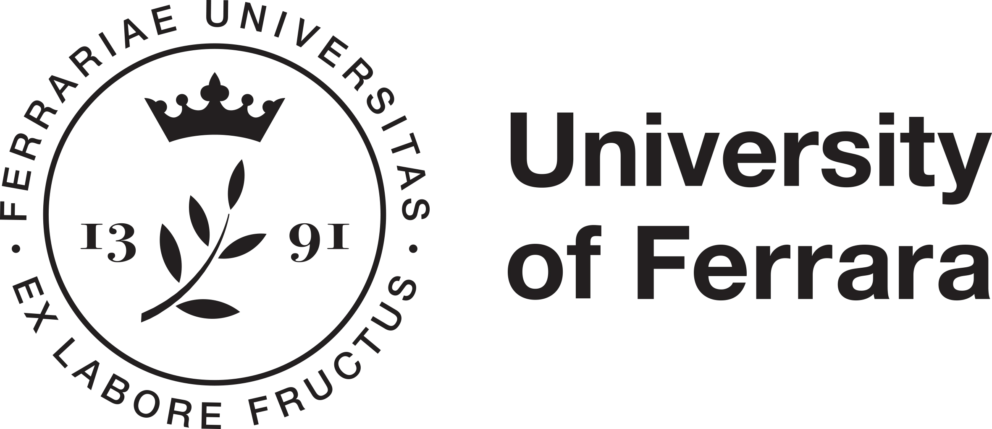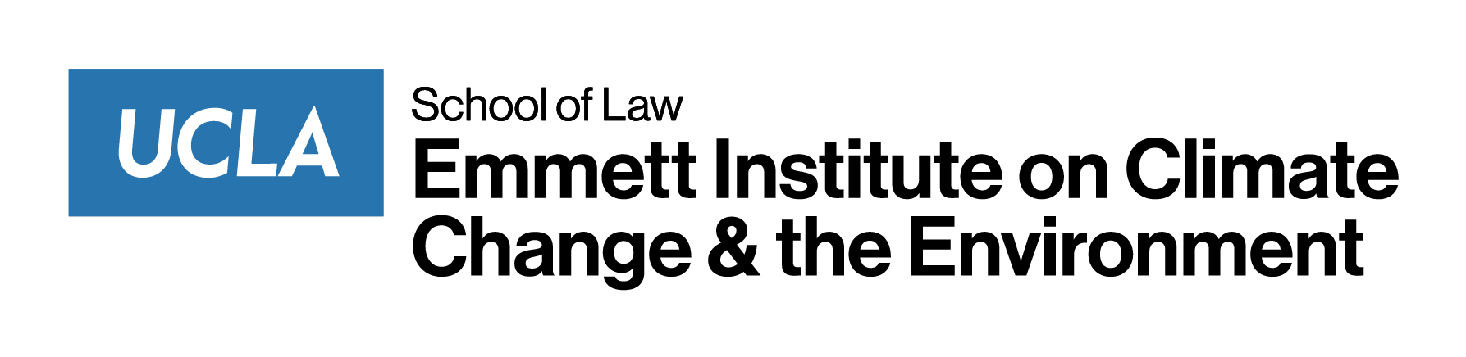

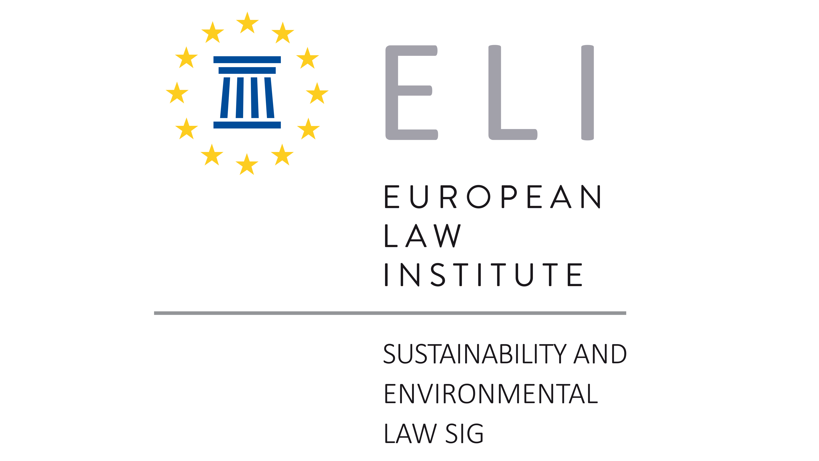

3rd Annual Conference on

Climate Justice –
New Challenges for Law and Judges

28 June 2024
University of Ferrara
Department of Law, Aula Magna
Corso Ercole I d’Este 37, Ferrara

Scientific Committee:
Henrik Andersen, William Boyd, Alberto De Franceschi, Matthias Keller

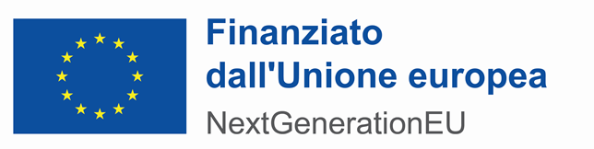

Background
Climate change issues are of cross-border nature, and the courts must deal with a multilevel system of law. In addition, the interface and overlap between specific international and EU climate change law, national and international public law, national and international private law, and criminal law, pose crucial methodological challenges for courts.
The risk we are already experiencing is that different methodological approaches can result in legal uncertainty to the detriment of citizens’ legitimate expectations under the rule of law.
The question is whether courts can find common ground for improved judicial cooperation in their methodological approaches to climate change problems in order to ensure improved legal certainty.
Similarly, while legislators may have ideas for new statutory rules for individuals, private entities and public administration, they need to understand what problems might exist and arise at the level of implementation.
This conference aims to explore and analyse issues relating to aspects which are relevant to the European Law Institute’s Project on “Climate Justice – New Challenges for Law and Judges”.

Friday, 28 June 2024

University of Ferrara, Department of Law, Aula Magna, Corso Ercole I d’Este, 37

09:00 Welcome addresses
Alberto De Franceschi (University of Ferrara)

09:10 Scope and Aims of the Conference
William Boyd (University of California, Los Angeles and
Director of the Emmet Institute on Climate Change and the Environment)

Matthias Keller (President of the Aachen Administrative Court
and European Association of Administrative Judges)

09:20 I. Setting the Scene

The European Green Deal as a Transformative Agenda for the Next Years?

Hugo Maria Schally (European Commission)

Opportunities and Challenges for Climate Change Law and Policies in the Context of World Trade Organization Law

Henrik Andersen (Copenhagen Business School)

10:00 II. Sustainability and Corporate Governance
Chair: Evelyne Terryn (KU Leuven)

Greening Corporate Law

Marc-Philippe Weller (University of Heidelberg)

Corporate Law as an Instrument of Environmental and Sustainability Regulation: Promises and Perils

Thilo Kuntz (University of Düsseldorf)

Principles of International Law in the Climate Justice Context

Rolf H. Weber (University of Zurich)

11:00 Discussion
11:20 Coffee Break

11:40 III. Supply Chains Governance and Greenwashing
Chair: Beate Gsell (Ludwig Maximilian University, Munich / Higher Regional Court of Munich)

Ecological Fallacies? ESG, Supply Chains, and Tropical Deforestation

William Boyd (University of California Los Angeles)

Complementarities for climate policy. Innovation, R&d and human capital

Massimiliano Mazzanti (University of Ferrara)

The EU Directive on Green Claims and Greenwashing

Evelyne Terryn (KU Leuven)

Enforcement Challenges in the Supply Chains

Paolo Cassinis (Autorità Garante della Concorrenza e del Mercato, Rome)

13:00 Discussion
13:30 Lunch

14:30 IV. Enforcement of Climate Related Issues
Chair: Eva-Maria Kieninger (University of Würzburg)

The Role of the ECHR in the Climate Litigation: General Principles
Raffaele Sabato (European Court of Human Rights)

The ECHR KlimaSeniorinnen Schweiz Case
Matthias Keller (Aachen Administrative Court)

Criminal Law Issues

Pasquale Fimiani (Advocate General at Supreme Court of Cassation, Rome)

Cities and Climate Litigation

Gabriel Wedy (Brazilian Federal Judge and Unisinos University)

15:50 Discussion
16:10 Coffee Break

16:30 V. Enforcement of Climate Related Issues
Chair: Gerhard Wagner (Humboldt University, Berlin) tbc

Is climate change litigation in front of civil court mere “strategic litigation”?

Eva-Maria Kieninger (University of Würzburg)

The due diligence standard in the Paris Agreement: a benchmark for climate cases

Christina Voigt (University of Oslo)

Duty of Care and Causation: The ENI Case

Claudio Scognamiglio (Tor Vergata University, Rome)

Duty of Care and Causation: The Royal Dutch Shell Case

Stijn Franken (NautaDutilh Law Firm, Amsterdam)

17:50 Discussion

18:30 Conclusions and Next Steps

***
Participation is free of charge.
Should you wish to attend,
please register by 20 June 2024
at: alberto.defranceschi@unife.it
***

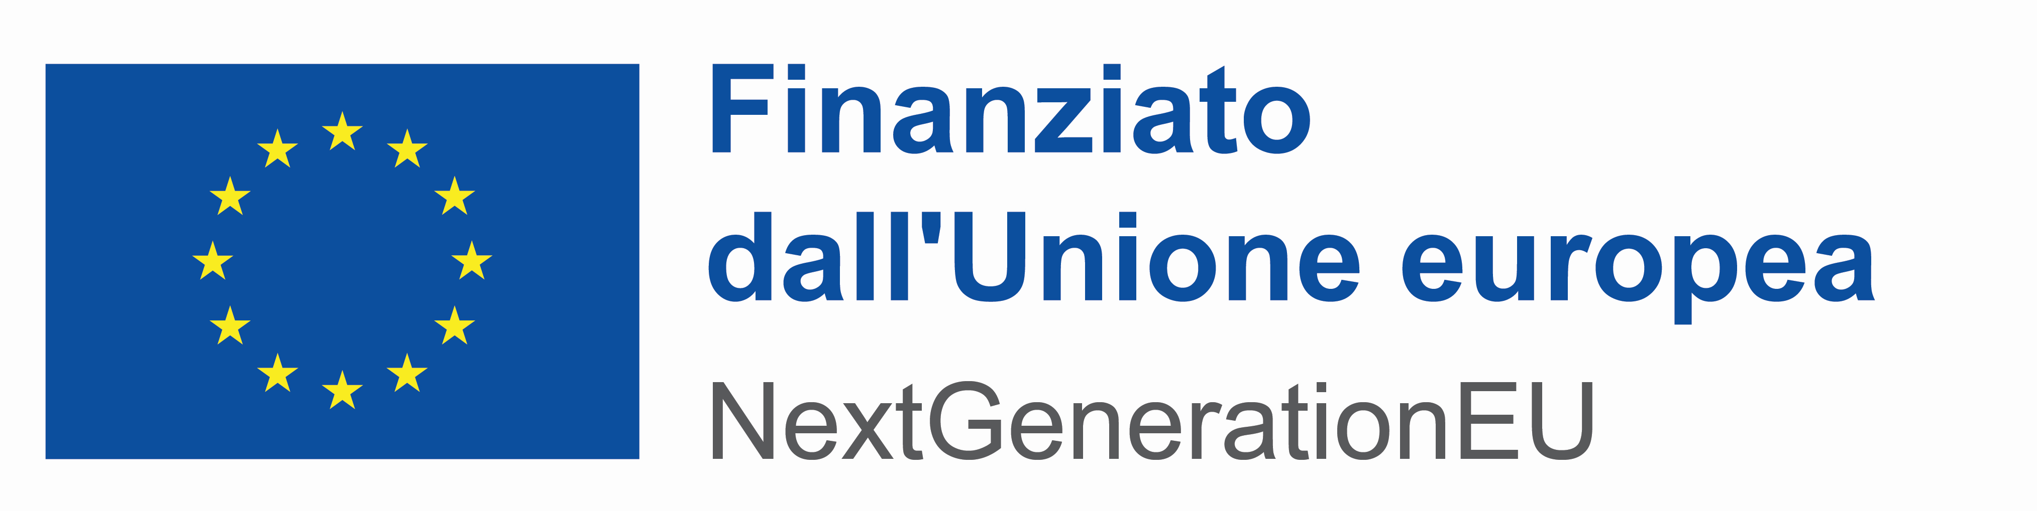
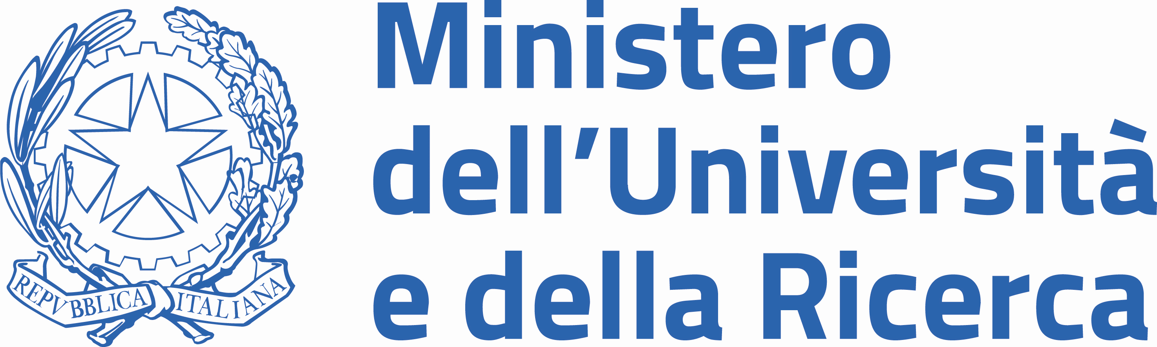
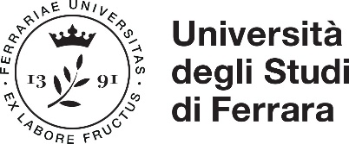
Piano Nazionale di Ripresa e Resilienza
Missione 4 - Componente 2 - Investimento 1.5 Creazione e rafforzamento di “ecosistemi dell’innovazione”, costruzione di “leader territoriali di R&S”
Titolo del progetto
Ecosystem for Sustainable Transition in Emilia-Romagna
Codice CUP
F78H22000410006
Soggetto attuatore
Università degli Studi di Ferrara
Obiettivo principale dell’operazione
- Corporate Governance,
Sustainability in the Supply Chain
and Climate Litigation -

